Assignment 1.1 22BCA136

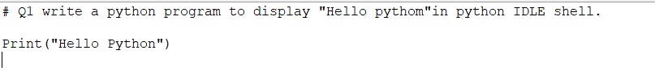



2. Write a python program to display hello python in window command prompt.



3. Write a python program to display “Hello Python” and “this our first class”Two different messages in one print statement only In both the python IDES.





Q4. Write a python program to display “Hello Python”, “This our first batch” and 2025 thee different messages in one print statement only in both the python IDEs

Q5. Write a program to display “Hello Python”, “This our first batch” and 2025 thee different messages in one print statement only in both the python IDEs





Q6. Write a program to declare variable called student_name and print the student name with Welcome Message in python IDLE shell.

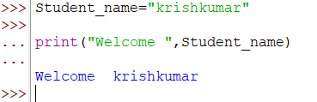

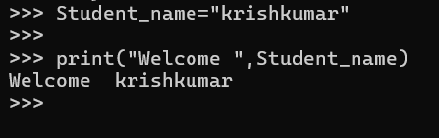

Q7. Write a python program to declare variables like student_name and student_age, Print the student name and age with static Message in Window Command Prompt.

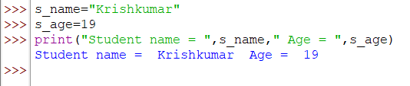

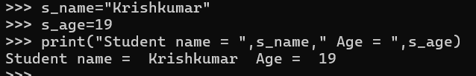

Q8. Write a program to check datatype of student_name and student_age in Window Command Prompt.

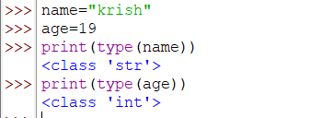

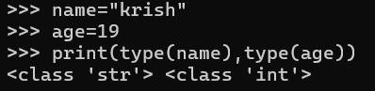

Q9. Write a python program to take name from user, store in variable and print the name with welcome message python IDLE shell.

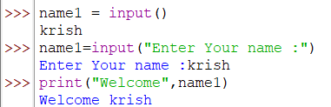

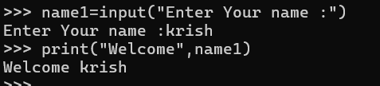

Q10. Write a program to ask user to enter 2 operand values, store into variables and perform arithmetic operations.

number1=float(input("Enter number1 : "))

number2=float(input("Enter number2 : "))

print("Number1 = ",number1," Number2 = ",number2)

print(number1," + ",number2," = ",(number1+number2))

print(number1," - ",number2," = ",(number1-number2))

print(number1," / ",number2," = ",(number1/number2))

print(number1," // ",number2," = ",(number1//number2))

print(number1," * ",number2," = ",(number1*number2))

print(number1," ** ",number2," = ",(number1**number2))

print(number1," % ",number2," = ",(number1%number2))

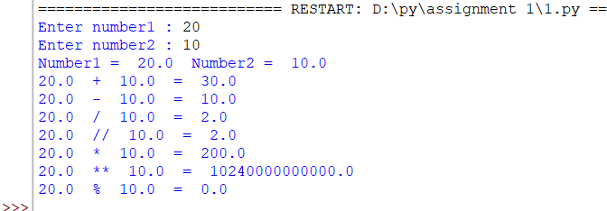

Q11. Write a program to ask user to enters following details, 1). First Name, 2). Last Name 3). City 4). Mobile Number 5). Email Id. Display these details in good format like any pdf file content. (can create new file in python IDLE shell)

f_name=input("Enter First Name : ")

by=int(input("Enter Your Born year : "))

l_name=input("Enter Last Name : ")

city=input("Enter City : ")

mobil=int(input("Enter mobile number : "))

email=input("Enter Email Id : ")

age = 2024-by

print("name : ",f_name)

print("age : ",age)

print("Last name : ",l_name)

print("City : ",city)

print("Mobile number : ",mobil)

print("Email ID : ",email)

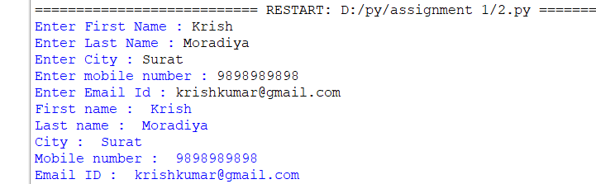

Q12. Write a program to ask user to enter their age, find the birth year and print it Window Command Prompt

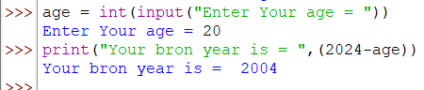

Q13. Write a program in new python file to ask user to enter name, birth year, calculate the age and print the calculated age with name.

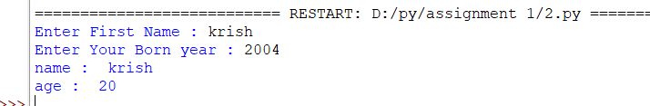

Q14. Write a program to ask teacher to enter students 5 subject marks, calculate percentage and print it in good format

eng=float(input("Enter marks of English : "))

guj=float(input("Enter marks of Gujrati : "))

com=float(input("Enter marks of Computer : "))

sci=float(input("Enter marks of Science : "))

ss=float(input("Enter marks of Social science : "))

print("English = ",eng)

print("Gujrati = ",guj)

print("Computer = ",com)

print("Science = ",sci)

print("Social Science = ",ss)

print("Percentage = ",((eng+guj+com+sci+ss)/5.0))

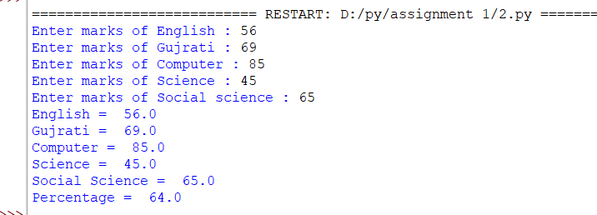

Q15. Write a program to ask Hr to enter employee details like, emp id, name, number of experience, current salary. Calculate 10% increment on the current salary and print incremented salary amount and updated salary.

emp_id=input("Enter Employee Id = ")

name=input("Enter Employee name= ")

experience=int(input("Enter Employee Experience number = "))

c_salary=float(input("Enter Employee Current salary = "))

i_sal =(c_salary*0.10)

print("Incremented salary is ",i_sal);

c_salary+=i_sal

print("Updated salary is ",c_salary)

